# GAIA-X - Vertical Data Space Education & Skills

Technical meeting – 2022-02-18

|  |  |  |
| --- | --- | --- |
| **Name** | **Country** | **Contact** |
| Ariño Martín, Lluís Alfons | Spain | [lluisalfons.arino@urv.cat](mailto:lluisalfons.arino@urv.cat) |
| ARO, Märt | Estonia | [aro.mart@gmail.com](mailto:aro.mart@gmail.com) |
| BOLE, Felix | France | [felix@visionspol.eu](mailto:felix@visionspol.eu) |
| CESTARI, Eric | France | [eric@cstar.io](mailto:eric@cstar.io) |
| CIMELLI, Claudio | France | [claudio.cimelli@education.gouv.fr](mailto:claudio.cimelli@education.gouv.fr) |
| De BIEVRES, Matthias | France | [matthias@visionspol.eu](mailto:matthias@visionspol.eu) |
| GRANDNE, Perrin | France | [perrin.grandne@education.gouv.fr](mailto:perrin.grandne@education.gouv.fr) |
| HUSTADT, Ralf | Luxembourg | [ralf.hustadt@luxinnovation.lu](mailto:ralf.hustadt@luxinnovation.lu) |
| IAGARTO, Vasco | Portugal | [vasco.lagarto@tice.pt](mailto:vasco.lagarto@tice.pt) |
| KENTIE, Erik | Netherlands | [erik.kentie@surf.nl](mailto:erik.kentie@surf.nl) |
| DIKKE, Diana | Germany | [diana.dikke@im-c.de](mailto:diana.dikke@im-c.de) |
| LINDSKOLD, Lars | Sweden | [lars.lindskold@vgregion.se](mailto:lars.lindskold@vgregion.se) |
| MINICHIELLO, Federica | France | [Minichiello@france-education-international.fr](mailto:Minichiello@france-education-international.fr) |
| NAUWERCK, Gerolf | Sweden | [gerolf.nauwerck@uu.se](mailto:gerolf.nauwerck@uu.se) |
| RIGO, Tommy | Sweden | [tommy.rigo@vgregion.se](mailto:tommy.rigo@vgregion.se) |
| SCHWERTEL, Uta | Germany | [Uta.Schwertel@im-c.de](mailto:Uta.Schwertel@im-c.de) |
| SIERLA, Mikko | Finland | [Mikko.Sierla@vastuugroup.fi](mailto:Mikko.Sierla@vastuugroup.fi) |
| SONNATI, Matthieu | France | [matt@inokufu.com](mailto:matt@inokufu.com) |

## **Part 1 : Identity**

*Presentation by Perrin Grandne, data architect working at French MoE on Education & Skills Data Space. Participates to GAIA-X technical working groups*

Links to the French collaborative platform about self-sovereign identity and the possible implementation of decentralized identity in the Data Space for Education & Skills (DaSES)

<https://prometheus-x.org/assemblies/dases-technical/f/87/posts/38>  
<https://prometheus-x.org/assemblies/dases-technical/f/84/debates/46>

List of available solutions and their level of progress, and GAIA-X “choices”: <https://gitlab.com/groups/gaia-x/lab/-/wikis/Initial-List-of-Solutions>  
<https://gitlab.com/groups/gaia-x/lab/-/wikis/Evaluation-of-SSI-Solutions>

=> Reaction about the complexity of applying a wallet system for K12.   
Different levels of decentralization can be considered, DID can be managed by a trusted entity, different MoEs could manage DIDs for students. No registry for trusted entity is currently available into Gaia-X.

=> French working group is working on a MVP of the Data Space Education & Skills ; Veramo/Uport has been chosen as DID solution ; they’re waiting for an implementation from Gaia-X for Verifiable Credentials solution.

## **Part 2 : Parallel works on identity**

1. **EBSI : several opportunities to align**

* European Digital ID wallet for citizens => Q1 2023
* Upcoming EBSI financing opportunities:
  + [**EBSI – Deployment of services**](https://ec.europa.eu/info/funding-tenders/opportunities/portal/screen/opportunities/topic-details/digital-2022-deploy-02-ebsi-services;callCode=null;freeTextSearchKeyword=DIGITAL-2022-DEPLOY-02;matchWholeText=true;typeCodes=1,0;statusCodes=31094501,31094502,31094503;programmePeriod=null;programCcm2Id=null;programDivisionCode=null;focusAreaCode=null;destination=null;mission=null;geographicalZonesCode=null;programmeDivisionProspect=null;startDateLte=null;startDateGte=null;crossCuttingPriorityCode=null;cpvCode=null;performanceOfDelivery=null;sortQuery=sortStatus;orderBy=asc;onlyTenders=false;topicListKey=topicSearchTablePageState)
  + [**Support to the implementation of the European Digital Identity Framework and the implementation of the Once Only System under the Single Digital Gateway**](https://ec.europa.eu/info/funding-tenders/opportunities/portal/screen/opportunities/topic-details/digital-2022-deploy-02-electronic-id;callCode=null;freeTextSearchKeyword=DIGITAL-2022-DEPLOY-02;matchWholeText=true;typeCodes=1,0;statusCodes=31094501,31094502,31094503;programmePeriod=null;programCcm2Id=null;programDivisionCode=null;focusAreaCode=null;destination=null;mission=null;geographicalZonesCode=null;programmeDivisionProspect=null;startDateLte=null;startDateGte=null;crossCuttingPriorityCode=null;cpvCode=null;performanceOfDelivery=null;sortQuery=sortStatus;orderBy=asc;onlyTenders=false;topicListKey=topicSearchTablePageState)
  + [**Blockchain Standardisation**](https://ec.europa.eu/info/funding-tenders/opportunities/portal/screen/opportunities/topic-details/digital-2022-deploy-02-blockchain-standard;callCode=null;freeTextSearchKeyword=DIGITAL-2022-DEPLOY-02;matchWholeText=true;typeCodes=1,0;statusCodes=31094501,31094502,31094503;programmePeriod=null;programCcm2Id=null;programDivisionCode=null;focusAreaCode=null;destination=null;mission=null;geographicalZonesCode=null;programmeDivisionProspect=null;startDateLte=null;startDateGte=null;crossCuttingPriorityCode=null;cpvCode=null;performanceOfDelivery=null;sortQuery=sortStatus;orderBy=asc;onlyTenders=false;topicListKey=topicSearchTablePageState)
  + [**Security (law enforcement): AI-based pilot**](https://ec.europa.eu/info/funding-tenders/opportunities/portal/screen/opportunities/topic-details/digital-2022-deploy-02-law-security-ai;callCode=null;freeTextSearchKeyword=DIGITAL-2022-DEPLOY-02;matchWholeText=true;typeCodes=1,0;statusCodes=31094501,31094502,31094503;programmePeriod=null;programCcm2Id=null;programDivisionCode=null;focusAreaCode=null;destination=null;mission=null;geographicalZonesCode=null;programmeDivisionProspect=null;startDateLte=null;startDateGte=null;crossCuttingPriorityCode=null;cpvCode=null;performanceOfDelivery=null;sortQuery=sortStatus;orderBy=asc;onlyTenders=false;topicListKey=topicSearchTablePageState)
* Interesting resources:
  + Wallet Conformance Test: <https://ec.europa.eu/digital-building-blocks/wikis/display/EBSIDOC/EBSI+Wallet+Conformance+Testing>
  + EBSI Verifiable Credentials Playbook (contains eSSIF DID method): <https://ec.europa.eu/digital-building-blocks/wikis/display/EBSIDOC/EBSI+Verifiable+Credentials+Playbook>
  + EBSI Generic Trust Framework for Issuing Credentials <https://drive.google.com/file/d/1_kFfGTCzAn460KBmKcrvWdJmv3TTBx1j/view?usp=sharing>
  + List of natural person wallets working in EBSI (open sourced + non-open sourced ones):

|  |
| --- |
| Wallet solutions and providers |
| BCdiploma wallet |
| CERTME by CERTSIGN |
| Custom wallet via Hyperledger Aries and Walt.ID |
| Custom wallet by DXC-Slovakia |
| Custom wallet by eLedger |
| CY-EBSI wallet |
| Diplo.me |
| ESATUS WALLET by ESATUS |
| GATACA Identity by GATACA |
| Hashnet by Tolar.net |
| Identyum wallet |
| InfoCert & Gradiant wallet use libs by SSIKIT |
| Protokol wallet |
| PWA by UNIKNAME |
| VERES WALLET by DIGITALBAZAAR via Danubetech |
| Vidchain by ValidateID |
| Walt.ID by WALT.ID |

### **Hints of stakeholders to gather on identity issues:**

* Finnish SSI project public-private implementation: <https://findy.fi/en/> (pilot stage).   
  Contact [mika.huhtamaki@vastuugroup.fi](mailto:mika.huhtamaki@vastuugroup.fi)
* NIIS: <https://www.niis.org/> (suggestion M. Sierla)
* GovStack.global (suggestion M. Aro)
* NIP <https://nordicinteroperability.com/> (suggestion L. Lindskold)

**Part 3 : Consent and Contract**   
*Demonstration of consent management by M. De Bièvres, CeO of Vision and president of Prometheus-X.* For further information: <https://github.com/Prometheus-X-association>

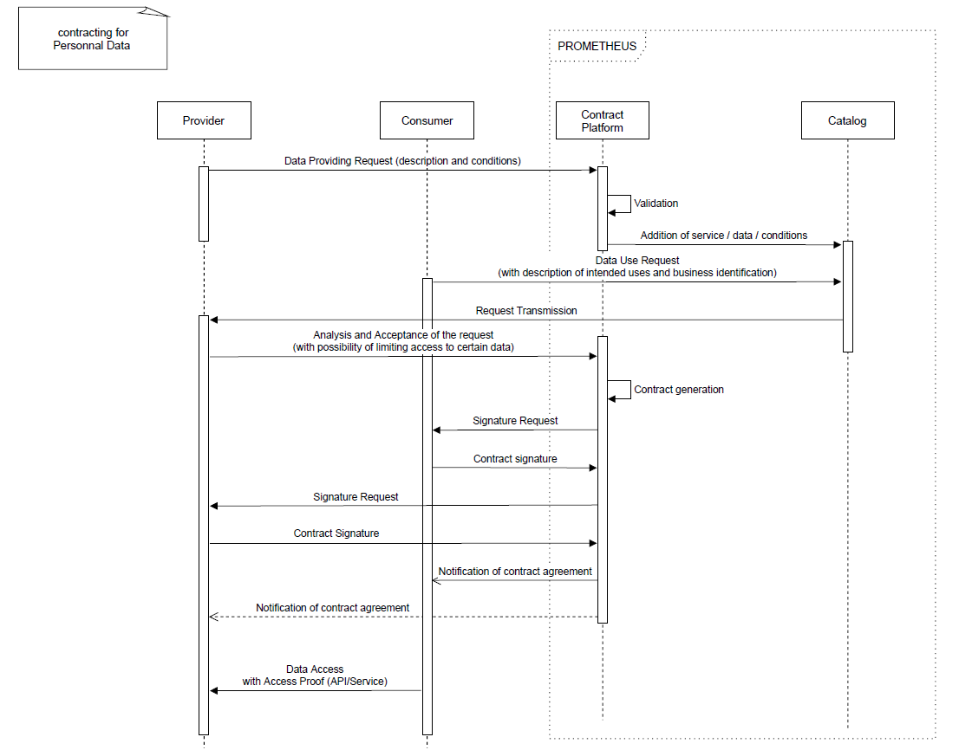

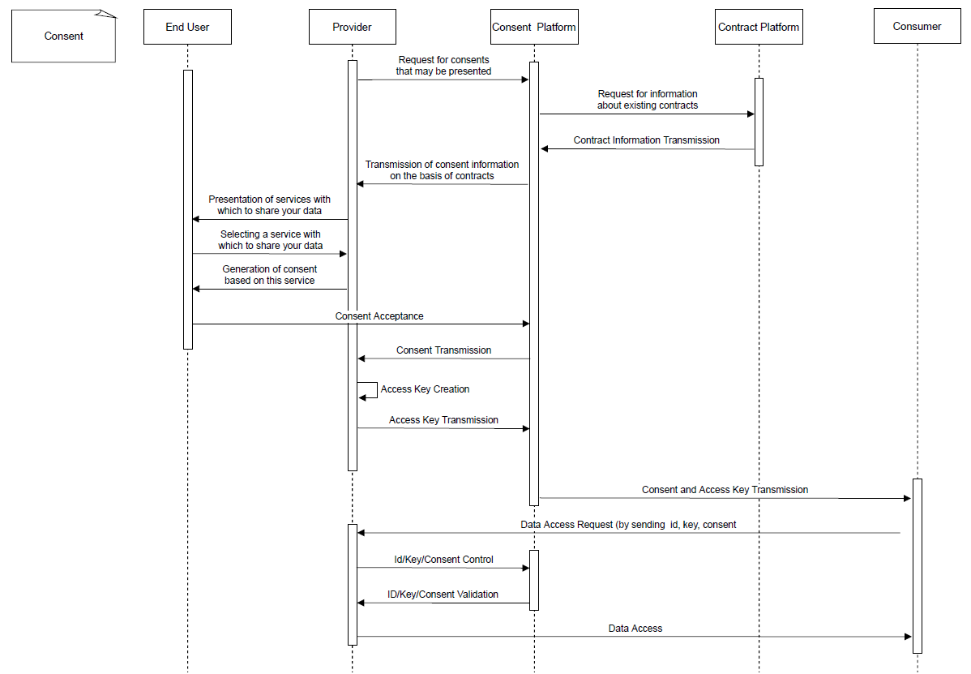

## **4. Conclusion & Next steps**

Several national projects on national data spaces

* Spain : CRUE Universidades (National Spanish Association of University Rectors) will work on the educational data space, and is willing to align with GAIA-X and European Data Spaces
* Estonia : working on public data lake for research, development of new solutions and personalization of learning solutions recommendation.
* France : Education Data Hub (national, K12) and Prometheus-X (Education & Skills, K12 and lifelong learning – aligned with GAIA-X)
* Etc.

Next steps

=> sub-meeting to be hosted, to go further on technical discussion on identity  
=> general vertical meeting, 3rd of March 10h30 => brainstorming pilot projects ideas