GAIA-X - Vertical Data Space Education & Skills
Technical meeting – 2022-02-18
Name | Country | Contact
Ariño Martín, Lluís Alfons | Spain | lluisalfons.arino@urv.cat
ARO, Märt | Estonia | aro.mart@gmail.com
BOLE, Felix | France | felix@visionspol.eu
CESTARI, Eric | France | eric@cstar.io
CIMELLI, Claudio | France | claudio.cimelli@education.gouv.fr
De BIEVRES, Matthias | France | matthias@visionspol.eu
GRANDNE, Perrin | France | perrin.grandne@education.gouv.fr
HUSTADT, Ralf | Luxembourg | ralf.hustadt@luxinnovation.lu
IAGARTO, Vasco | Portugal | vasco.lagarto@tice.pt
KENTIE, Erik | Netherlands | erik.kentie@surf.nl
DIKKE, Diana | Germany | diana.dikke@im-c.de
LINDSKOLD, Lars | Sweden | lars.lindskold@vgregion.se
MINICHIELLO, Federica | France | Minichiello@france-education-international.fr
NAUWERCK, Gerolf | Sweden | gerolf.nauwerck@uu.se
RIGO, Tommy | Sweden | tommy.rigo@vgregion.se
SCHWERTEL, Uta | Germany | Uta.Schwertel@im-c.de
SIERLA, Mikko | Finland | Mikko.Sierla@vastuugroup.fi
SONNATI, Matthieu | France | matt@inokufu.com

Part 1 : Identity
Presentation by Perrin Grandne, data architect working at French MoE on Education & Skills Data Space. Participates to GAIA-X technical working groups
Links to the French collaborative platform about self-sovereign identity and the possible implementation of decentralized identity in the Data Space for Education & Skills (DaSES)
https://prometheus-x.org/assemblies/dases-technical/f/87/posts/38
https://prometheus-x.org/assemblies/dases-technical/f/84/debates/46
List of available solutions and their level of progress, and GAIA-X “choices”: https://gitlab.com/groups/gaia-x/lab/-/wikis/Initial-List-of-Solutions
https://gitlab.com/groups/gaia-x/lab/-/wikis/Evaluation-of-SSI-Solutions
=> Reaction about the complexity of applying a wallet system for K12.
Different levels of decentralization can be considered, DID can be managed by a trusted entity, different MoEs could manage DIDs for students. No registry for trusted entity is currently available into Gaia-X.
=> French working group is working on a MVP of the Data Space Education & Skills ; Veramo/Uport has been chosen as DID solution ; they’re waiting for an implementation from Gaia-X for Verifiable Credentials solution.

Part 2 : Parallel works on identity
- EBSI : several opportunities to align
- European Digital ID wallet for citizens => Q1 2023
- Upcoming EBSI financing opportunities:
  - EBSI – Deployment of services
  - Support to the implementation of the European Digital Identity Framework and the implementation of the Once Only System under the Single Digital Gateway
  - Blockchain Standardisation
  - Security (law enforcement): AI-based pilot
- Interesting resources:
  - Wallet Conformance Test: https://ec.europa.eu/digital-building-blocks/wikis/display/EBSIDOC/EBSI+Wallet+Conformance+Testing
  - EBSI Verifiable Credentials Playbook (contains eSSIF DID method): https://ec.europa.eu/digital-building-blocks/wikis/display/EBSIDOC/EBSI+Verifiable+Credentials+Playbook
  - EBSI Generic Trust Framework for Issuing Credentials https://drive.google.com/file/d/1_kFfGTCzAn460KBmKcrvWdJmv3TTBx1j/view?usp=sharing
  - List of natural person wallets working in EBSI (open sourced + non-open sourced ones):
Wallet solutions and providers
BCdiploma wallet
CERTME by CERTSIGN
Custom wallet via Hyperledger Aries and Walt.ID
Custom wallet by DXC-Slovakia
Custom wallet by eLedger
CY-EBSI wallet
Diplo.me
ESATUS WALLET by ESATUS
GATACA Identity by GATACA
Hashnet by Tolar.net
Identyum wallet
InfoCert & Gradiant wallet use libs by SSIKIT
Protokol wallet
PWA by UNIKNAME
VERES WALLET by DIGITALBAZAAR via Danubetech
Vidchain by ValidateID
Walt.ID by WALT.ID

Hints of stakeholders to gather on identity issues:
- Finnish SSI project public-private implementation: https://findy.fi/en/ (pilot stage).
Contact mika.huhtamaki@vastuugroup.fi
- NIIS: https://www.niis.org/ (suggestion M. Sierla)
- GovStack.global (suggestion M. Aro)
- NIP https://nordicinteroperability.com/ (suggestion L. Lindskold)
Part 3 : Consent and Contract
Demonstration of consent management by M. De Bièvres, CeO of Vision and president of Prometheus-X. For further information: https://github.com/Prometheus-X-association
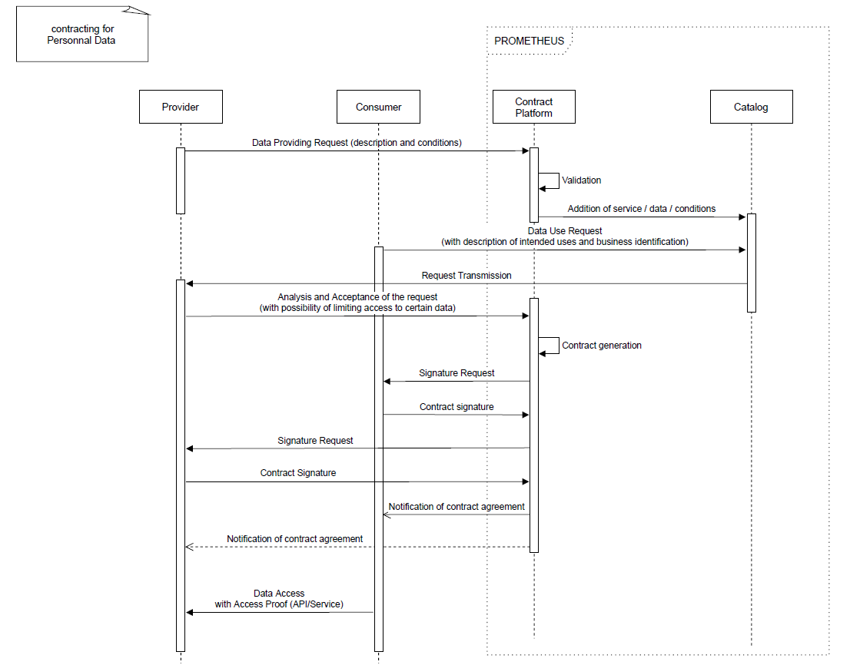
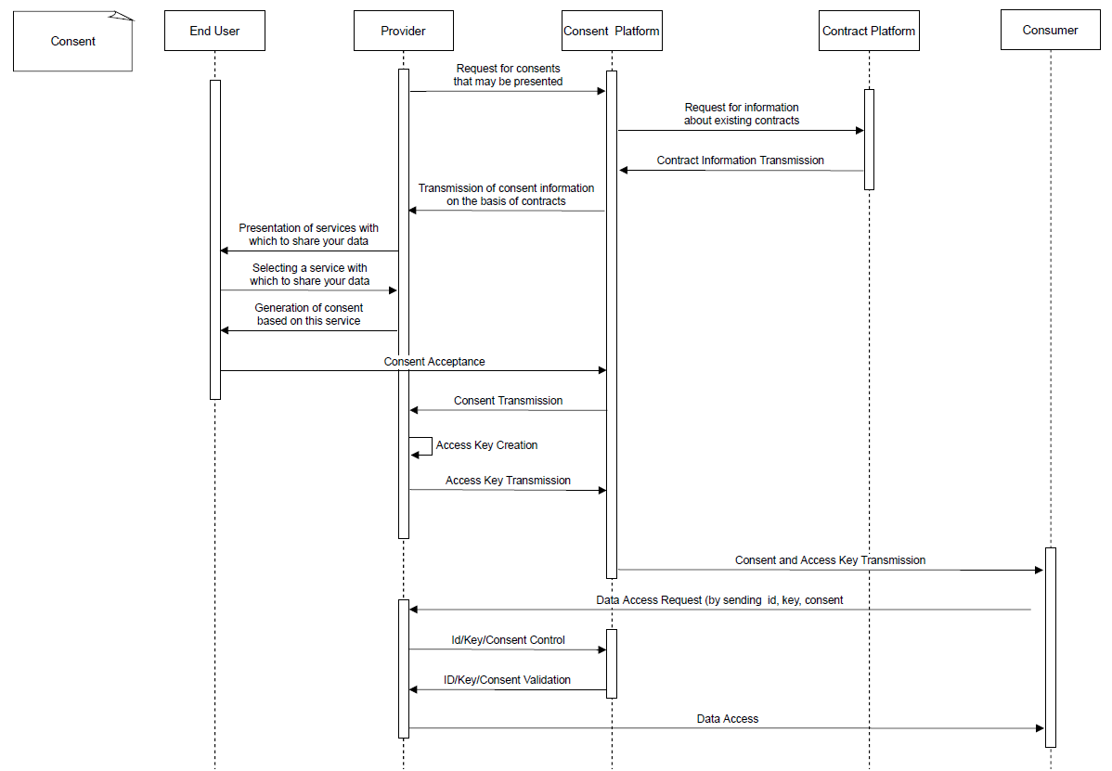

4. Conclusion & Next steps
Several national projects on national data spaces
- Spain : CRUE Universidades (National Spanish Association of University Rectors) will work on the educational data space, and is willing to align with GAIA-X and European Data Spaces
- Estonia : working on public data lake for research, development of new solutions and personalization of learning solutions recommendation.
- France : Education Data Hub (national, K12) and Prometheus-X (Education & Skills, K12 and lifelong learning – aligned with GAIA-X)
- Etc.
Next steps
=> sub-meeting to be hosted, to go further on technical discussion on identity
=> general vertical meeting, 3rd of March 10h30 => brainstorming pilot projects ideas

